Enhanced User Security with SUDO
Tasks
1.Create a new user account called zomatoadmin on your Linux system, and configure it so that this user can run only the apt-get update and apt-get upgrade commands using sudo without entering a password.Hint: Edit the /etc/sudoers file using visudo and use the NOPASSWD directive for specific commands.
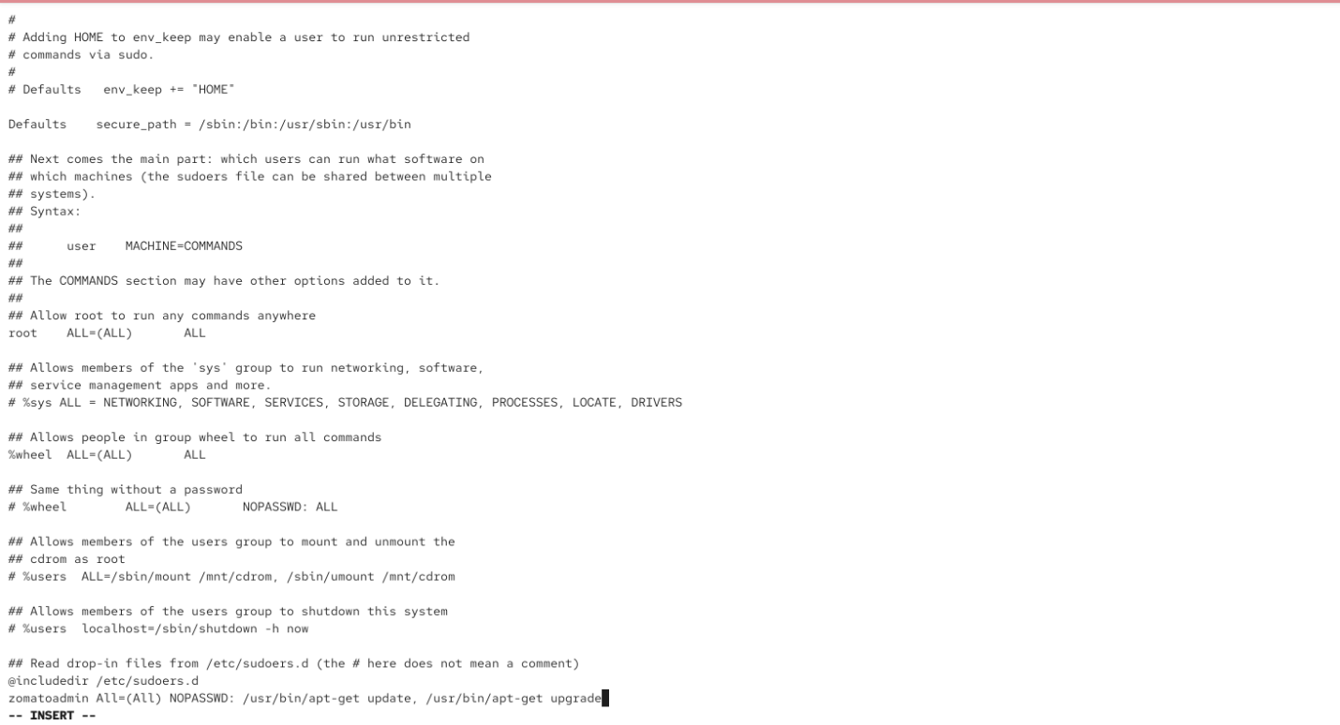
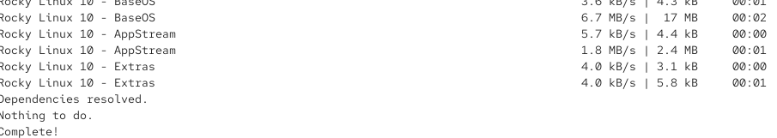
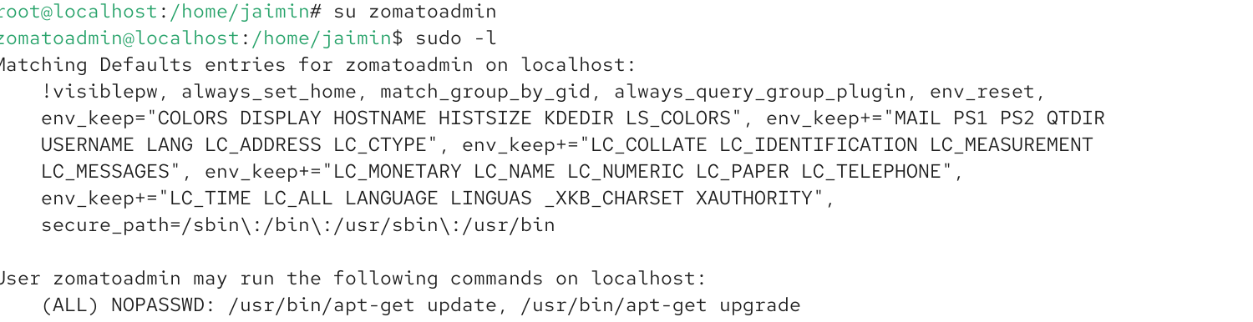

2.Modify the sudo privileges for your existing user so that they cannot run sudo rm -rf / but can run all other sudo commands.Constraint: Use command-specific restrictions in the sudoers file to block only the dangerous command.

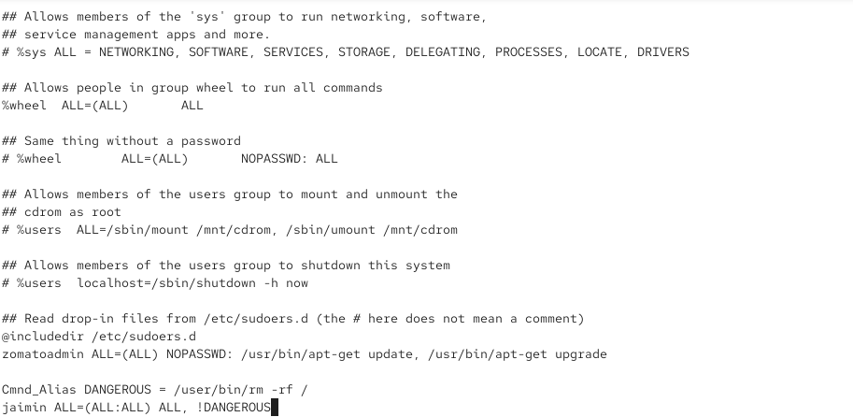
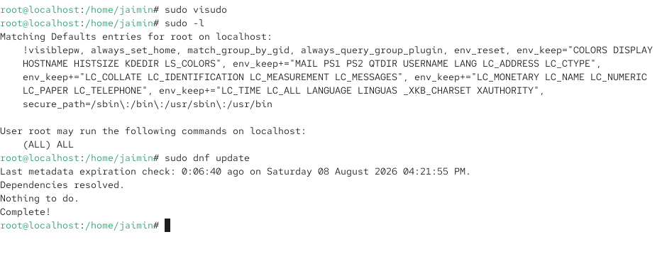
3.Simulate a scenario where a user tries to run a command with sudo that they are not allowed to. Take a screenshot of the error message and explain in 2-3 lines why the error occurs based on your sudoers configuration.

4.Set up a group called myntragroup and add two users to it. Grant sudo privileges to this group so that all members can restart the networking service (systemctl restart networking) but cannot edit any files in /etc.

